Step 1:

Kryejmë konfigurimin sipas kërkesës

Konfigurimi I R1 , po ashtu dhe për R2 dhe R3.

Paraqitja e re e CLI.

Step 2:

Step 3,4,5:

Kryejmë një ping nga default gateway i PC3 dhe shoim qe rrjeti punon

Skema e ndërtuar

Task: Configure OSPF on the R1 Router

Task: Configure OSPF on the R2 and R3 Routers

Task: Configure OSPF Router IDs

Step 1:

* What is the router ID for R1? Router ID 192.168.10.5
* What is the router ID for R2? Router ID 192.168.10.9
* What is the router ID for R3? Router ID 192.168.10.10

Step 2:

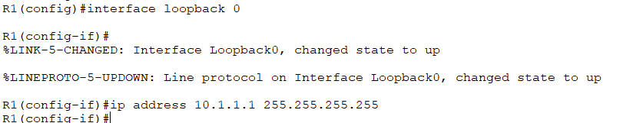

Step 3:

* When the router is reloaded, what is the router ID for R1? Router ID 10.1.1.1
* When the router is reloaded, what is the router ID for R2? Router ID 10.2.2.2
* When the router is reloaded, what is the router ID for R3? Router ID 10.3.3.3

Step 4:

Step 5:

Step 6:

Step 7:

Step 8:

Task: Verify OSPF Operation.

Step 1:

Step 2:

Task: Examine OSPF Routes in the Routing Tables

